SmartSure Insurance Management System

Project Requirement Document (Microservices)
Spring Boot • Spring Cloud Microservices (4) • Spring Cloud Gateway • PostgreSQL / MySQL • Spring Data JPA • Swagger / OpenAPI • JWT•React/Angular

A) Application Overview
SmartSure Insurance Management System is a microservices-based backend platform designed to digitize the complete insurance lifecycle. Customers can register, purchase insurance policies, calculate premiums, upload claim documents, and initiate insurance claims through secure REST APIs.
Administrative users manage insurance products, verify claim documentation, approve or reject claims, and generate operational reports.
The system is built using Spring Boot microservices, with Spring Cloud Gateway acting as the API gateway for routing requests to backend services. Each microservice maintains its own database and communicates with other services through REST APIs or OpenFeign clients,Front End REACT or Angular.

B) Objective
• Digitize policy purchase and claim settlement workflows
• Reduce manual processing using workflow-based status transitions
• Implement secure APIs using Spring Security + JWT authentication
• Demonstrate enterprise-grade Spring Cloud microservices architecture
• Provide reporting APIs for operational monitoring

C) Roles & Access Control

Roles

Customer (Policy Holder)
• Register and login
• Purchase insurance policies
• View purchased policies and details
• Upload claim documents
• Initiate insurance claims
• Track claim status

Admin
• Manage insurance policy products
• Review and verify claim documentation
• Approve or reject claims
• Generate operational reports
• Manage system users

Security Implementation
Security is implemented using Spring Security and JWT authentication.
Security Features
• JWT Bearer authentication
• Role-based authorization
• Secure API gateway routing
• Method-level authorization using annotations
Example:
@PreAuthorize("hasRole('ADMIN')")
All client requests pass through Spring Cloud Gateway before reaching backend microservices.

D) Backend System Architecture
The system follows a Spring Boot microservices architecture where each service is independently deployed and manages its own database.
All APIs are documented using Swagger / OpenAPI.
Clients interact with the system through REST APIs exposed by the API Gateway.

E) Functional API Modules
The system exposes APIs to support the following operations.

1. User Registration
Purpose
Register a new customer in the system.
API
POST /api/auth/register
Fields
• name
• email
• password
• phone
• address

2. User Login
Purpose
Authenticate users and generate a JWT token.
API
POST /api/auth/login
Response
{
"token": "JWT_TOKEN",
"role": "CUSTOMER"
}

3. Purchase Insurance Policy
Purpose
Allow customers to purchase insurance policies.
API
POST /api/policies/purchase

4. View Policy Details
GET /api/policies/{policyId}

5. Upload Claim Documents
POST /api/claims/upload
Supported file types
• PDF
• Images

6. Initiate Claim
POST /api/claims/initiate

7. Track Claim Status
GET /api/claims/status/{claimId}

8. Admin Claim Review
PUT /api/admin/claims/{claimId}/review

9. Policy Product Management
Admin APIs
POST /api/admin/policies
PUT /api/admin/policies/{id}
DELETE /api/admin/policies/{id}

10. Reports
GET /api/admin/reports

F) Status Lifecycle

Policy Lifecycle
CREATED → ACTIVE → EXPIRED → CANCELLED
Customer
CREATED → ACTIVE
Admin
ACTIVE → CANCELLED

Claim Lifecycle
DRAFT → SUBMITTED → UNDER_REVIEW → APPROVED / REJECTED → CLOSED
Customer
DRAFT → SUBMITTED
Admin
UNDER_REVIEW → APPROVED / REJECTED
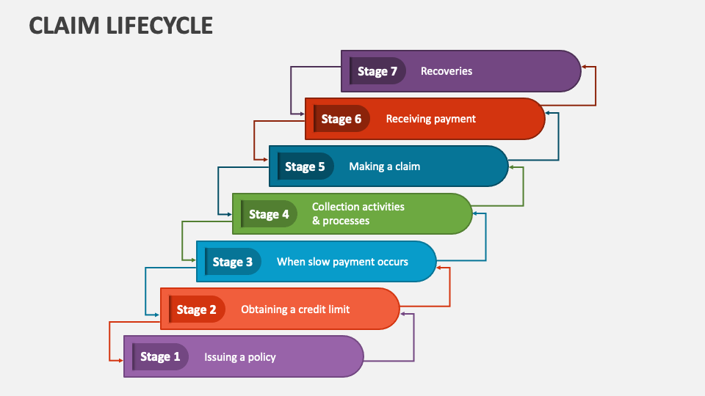
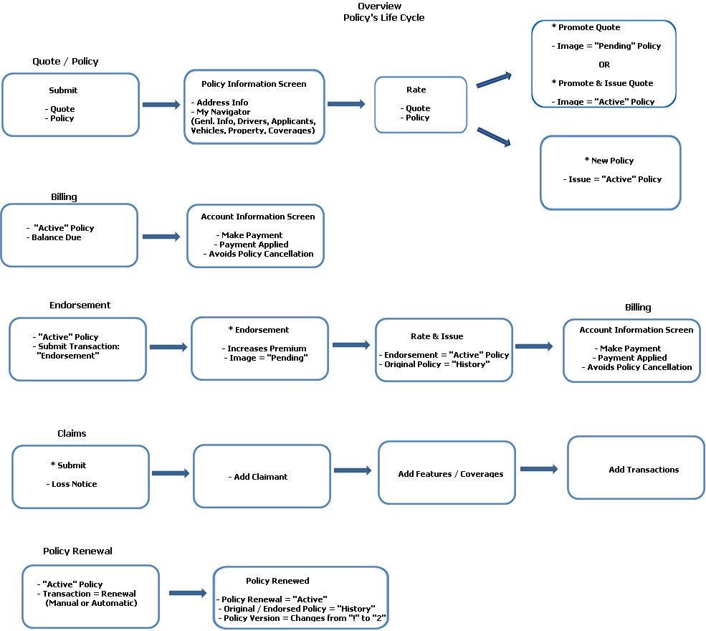

G) Microservices System Architecture

Architecture Overview
Clients send requests to Spring Cloud Gateway.
Gateway routes requests to backend microservices registered with Eureka Service Discovery.
Each microservice maintains its own database and business logic.
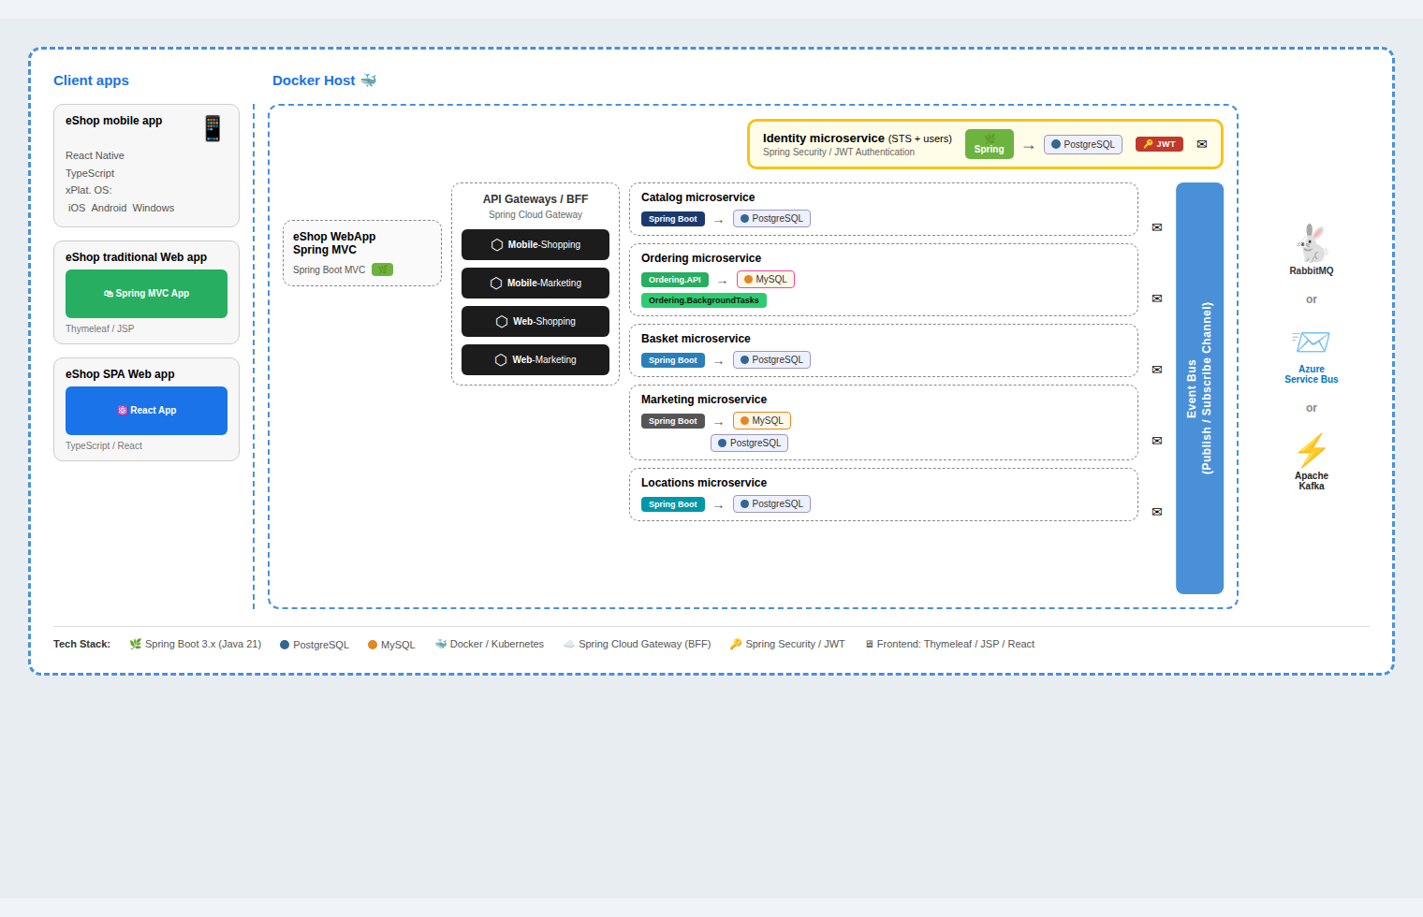

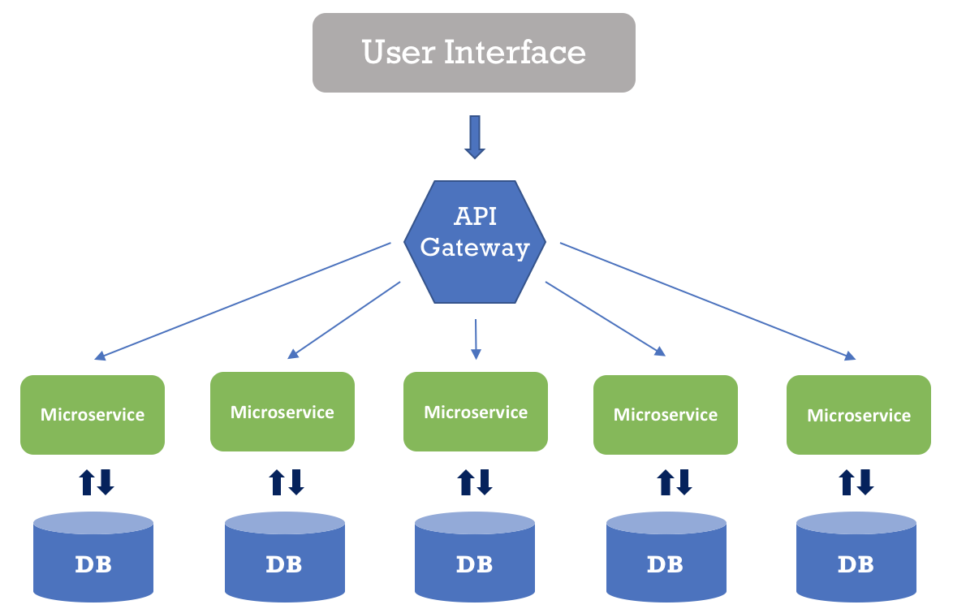

Microservices

1) Auth Service
Responsibilities
• User registration
• Login authentication
• JWT token generation
• Role management

2) Policy Service
Responsibilities
• Insurance policy products
• Policy purchase
• Premium calculation

3) Claims Service
Responsibilities
• Claim submission
• Document upload
• Claim verification

4) Admin / Reporting Service
Responsibilities
• Claim approvals
• User management
• Reports and dashboards

H) Database Design (Spring Data JPA)
Each microservice manages its own database using Spring Data JPA and Hibernate ORM.
Core Entities
• Users
• Policies
• PolicyTypes
• Premiums
• Claims
• ClaimDocuments
• Payments
Development Flow
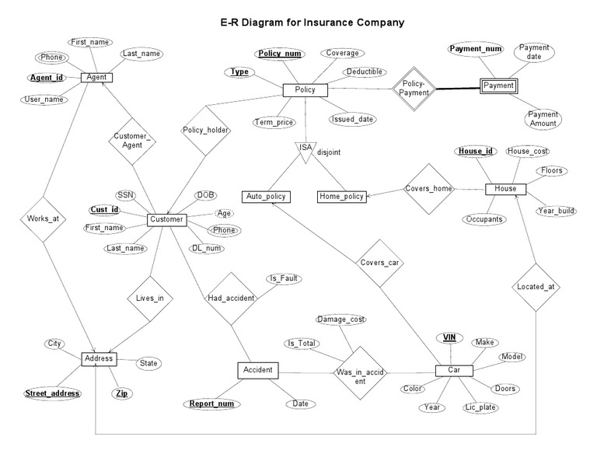
Entity → Repository → Service → Controller
Database schema is generated automatically using Hibernate JPA.

I) REST API Documentation
All microservices provide API documentation using Swagger / OpenAPI.
API Testing Tools
• Swagger UI
• Postman

J) Software Required

Backend Development
• Java 17
• Spring Boot
• Maven
• IntelliJ IDEA / Spring Tool Suite/Eclipse

Database
• PostgreSQL or MySQL
• pgAdmin / MySQL Workbench

API Testing
• Postman

K) Testing & Quality Plan
Backend Testing
• JUnit 5
• Mockito
Testing Scope
• Service layer testing
• Controller testing
• Repository testing
Frontend (Jasmine/Cucumber)
• Component tests
• Service & guard tests

Expected Code Coverage
≥ 90%

L) Student Deliverables
Students must submit the following diagrams and documentation.
- Use Case Diagram
- UML Class Diagram
- Sequence Diagram (Policy Purchase / Claim Flow)
- Component Diagram (Microservices Architecture)
- Deployment Diagram

M) Test Cases (Sample)
Test Case | Role | Expected Result | Type | Service
Signup | Customer | Account created | Positive | Auth
Login | Customer | JWT issued | Positive | Auth
Buy Policy | Customer | Policy activated | Positive | Policy
Initiate Claim | Customer | Claim submitted | Positive | Claims
Approve Claim | Admin | Claim approved | Positive | Admin
Unauthorized Access | Customer | 403 Forbidden | Security | Gateway

N) Deliverables & Evaluation Criteria
Area | Weightage
Microservices Architecture | 20%
Security (JWT + Spring Security) | 15%
Database Design | 15%
Swagger API Documentation | 15%
Testing Coverage | 20%
UML Diagrams | 15%

O) Conclusion
This document provides a complete blueprint for building an Insurance Management System using Spring Boot microservices and Spring Cloud architecture.
The system demonstrates enterprise backend development practices including:
• Spring Boot Microservices
• Spring Cloud Gateway
• Service Discovery using Eureka
• Secure APIs using JWT authentication
• Swagger API documentation
• Independent scalable microservices architecture
This project is suitable for corporate training, academic evaluation, and real-world system design learning.

📲 Screen Design (Wireframes)(React/Angular)
